DBMS - File Structure
Relative data and information is stored collectively in file formats. A file is a sequence of records stored in binary format. A disk drive is formatted into several blocks that can store records. File records are mapped onto those disk blocks.

File Organization
File Organization defines how file records are mapped onto disk blocks. We have four types of File Organization to organize file records −
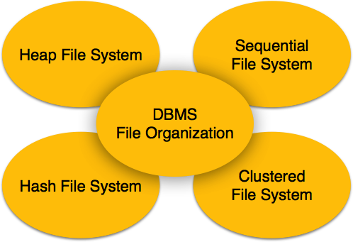

Objective of file organization
- It contains an optimal selection of records, i.e., records can be selected as fast as possible.
- To perform insert, delete or update transaction on the records should be quick and easy.
- The duplicate records cannot be induced as a result of insert, update or delete.
- For the minimal cost of storage, records should be stored efficiently.

Types of file organization:
File organization contains various methods. These particular methods have pros and cons on the basis of access or selection. In the file organization, the programmer decides the best-suited file organization method according to his requirement.
Types of file organization are as follows:
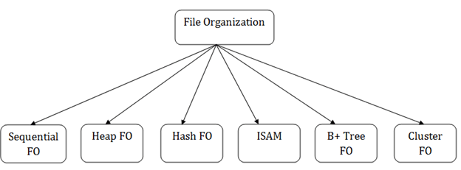
- Sequential file organization
- Heap file organization
- Hash file organization
- B+ file organization
- Indexed sequential access method (ISAM)
- Cluster file organization

Heap File Organization
When a file is created using Heap File Organization, the Operating System allocates memory area to that file without any further accounting details. File records can be placed anywhere in that memory area. It is the responsibility of the software to manage the records. Heap File does not support any ordering, sequencing, or indexing on its own.

Heap file organization
- It is the simplest and most basic type of organization. It works with data blocks. In heap file organization, the records are inserted at the file's end. When the records are inserted, it doesn't require the sorting and ordering of records.
- When the data block is full, the new record is stored in some other block. This new data block need not to be the very next data block, but it can select any data block in the memory to store new records. The heap file is also known as an unordered file.
- In the file, every record has a unique id, and every page in a file is of the same size. It is the DBMS responsibility to store and manage the new records.
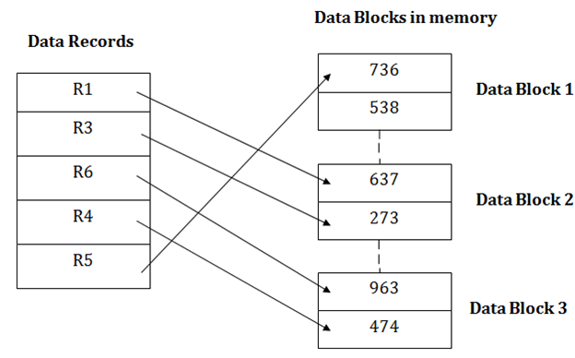

Insertion of a new record
Suppose we have five records R1, R3, R6, R4 and R5 in a heap and suppose we want to insert a new record R2 in a heap. If the data block 3 is full then it will be inserted in any of the database selected by the DBMS, let's say data block 1.
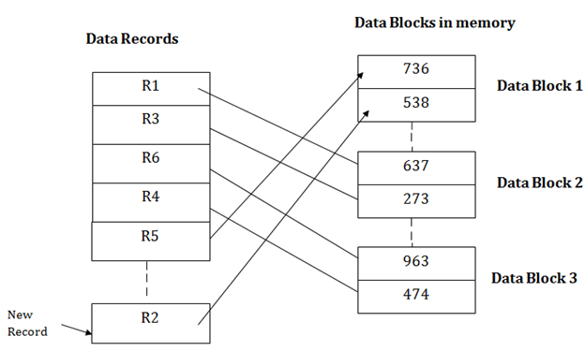
If we want to search, update or delete the data in heap file organization, then we need to traverse the data from staring of the file till we get the requested record.
If the database is very large then searching, updating or deleting of record will be time-consuming because there is no sorting or ordering of records. In the heap file organization, we need to check all the data until we get the requested record.

Pros of Heap file organization
- It is a very good method of file organization for bulk insertion. If there is a large number of data which needs to load into the database at a time, then this method is best suited.
- In case of a small database, fetching and retrieving of records is faster than the sequential record.

Cons of Heap file organization
- This method is inefficient for the large database because it takes time to search or modify the record.

- This method is inefficient for large databases.

Sequential File Organization
Every file record contains a data field (attribute) to uniquely identify that record. In sequential file organization, records are placed in the file in some sequential order based on the unique key field or search key. Practically, it is not possible to store all the records sequentially in physical form.

Sequential File Organization
This method is the easiest method for file organization. In this method, files are stored sequentially. This method can be implemented in two ways:

1. Pile File Method:
- It is a quite simple method. In this method, we store the record in a sequence, i.e., one after another. Here, the record will be inserted in the order in which they are inserted into tables.
- In case of updating or deleting of any record, the record will be searched in the memory blocks. When it is found, then it will be marked for deleting, and the new record is inserted.
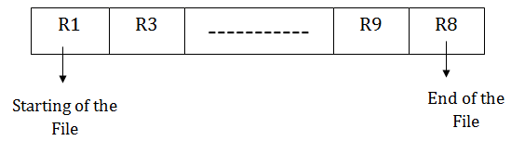

Insertion of the new record:
Suppose we have four records R1, R3 and so on upto R9 and R8 in a sequence. Hence, records are nothing but a row in the table. Suppose we want to insert a new record R2 in the sequence, then it will be placed at the end of the file. Here, records are nothing but a row in any table.
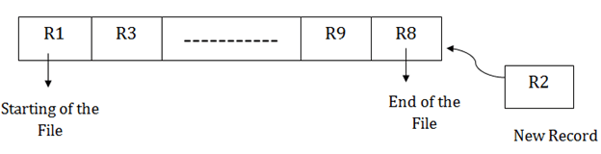

2. Sorted File Method:
- In this method, the new record is always inserted at the file's end, and then it will sort the sequence in ascending or descending order. Sorting of records is based on any primary key or any other key.
- In the case of modification of any record, it will update the record and then sort the file, and lastly, the updated record is placed in the right place.


Insertion of the new record:
Suppose there is a preexisting sorted sequence of four records R1, R3 and so on upto R6 and R7. Suppose a new record R2 has to be inserted in the sequence, then it will be inserted at the end of the file, and then it will sort the sequence.
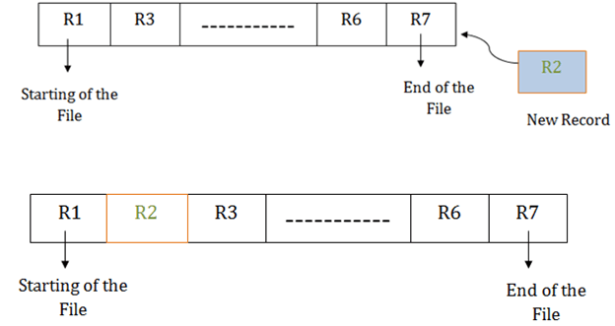

Pros of sequential file organization
- It contains a fast and efficient method for the huge amount of data.
- In this method, files can be easily stored in cheaper storage mechanism like magnetic tapes.
- It is simple in design. It requires no much effort to store the data.
- This method is used when most of the records have to be accessed like grade calculation of a student, generating the salary slip, etc.
- This method is used for report generation or statistical calculations.

Cons of sequential file organization
- It will waste time as we cannot jump on a particular record that is required but we have to move sequentially which takes our time.
- Sorted file method takes more time and space for sorting the records.

Hash File Organization
Hash File Organization uses Hash function computation on some fields of the records. The output of the hash function determines the location of disk block where the records are to be placed.

Hash File Organization
Hash File Organization uses the computation of hash function on some fields of the records. The hash function's output determines the location of disk block where the records are to be placed.
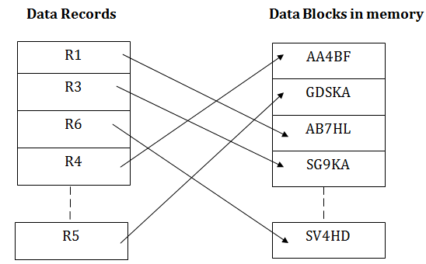
When a record has to be received using the hash key columns, then the address is generated, and the whole record is retrieved using that address. In the same way, when a new record has to be inserted, then the address is generated using the hash key and record is directly inserted. The same process is applied in the case of delete and update.
In this method, there is no effort for searching and sorting the entire file. In this method, each record will be stored randomly in the memory.
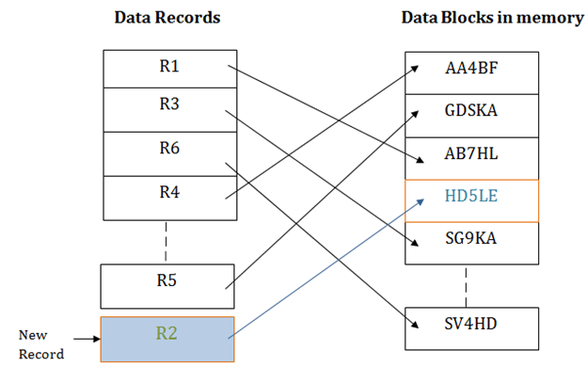

Clustered File Organization
Clustered file organization is not considered good for large databases. In this mechanism, related records from one or more relations are kept in the same disk block, that is, the ordering of records is not based on primary key or search key.

Cluster file organization
- When the two or more records are stored in the same file, it is known as clusters. These files will have two or more tables in the same data block, and key attributes which are used to map these tables together are stored only once.
- This method reduces the cost of searching for various records in different files.
- The cluster file organization is used when there is a frequent need for joining the tables with the same condition. These joins will give only a few records from both tables. In the given example, we are retrieving the record for only particular departments. This method can't be used to retrieve the record for the entire department.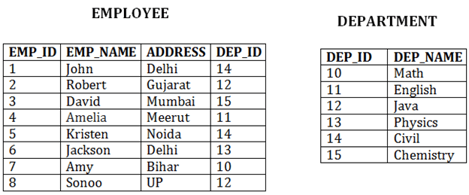
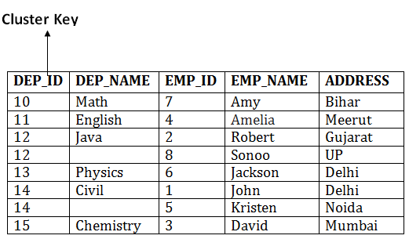
In this method, we can directly insert, update or delete any record. Data is sorted based on the key with which searching is done. Cluster key is a type of key with which joining of the table is performed.

Types of Cluster file organization:
Cluster file organization is of two types:

1. Indexed Clusters:
In indexed cluster, records are grouped based on the cluster key and stored together. The above EMPLOYEE and DEPARTMENT relationship is an example of an indexed cluster. Here, all the records are grouped based on the cluster key- DEP_ID and all the records are grouped.

2. Hash Clusters:
It is similar to the indexed cluster. In hash cluster, instead of storing the records based on the cluster key, we generate the value of the hash key for the cluster key and store the records with the same hash key value.

Pros of Cluster file organization
- The cluster file organization is used when there is a frequent request for joining the tables with same joining condition.
- It provides the efficient result when there is a 1:M mapping between the tables.

Cons of Cluster file organization
- This method has the low performance for the very large database.
- If there is any change in joining condition, then this method cannot use. If we change the condition of joining then traversing the file takes a lot of time.
- This method is not suitable for a table with a 1:1 condition.

B+ File Organization
- B+ tree file organization is the advanced method of an indexed sequential access method. It uses a tree-like structure to store records in File.
- It uses the same concept of key-index where the primary key is used to sort the records. For each primary key, the value of the index is generated and mapped with the record.
- The B+ tree is similar to a binary search tree (BST), but it can have more than two children. In this method, all the records are stored only at the leaf node. Intermediate nodes act as a pointer to the leaf nodes. They do not contain any records.
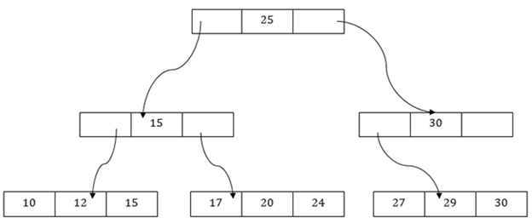

The above B+ tree shows that:
- There is one root node of the tree, i.e., 25.
- There is an intermediary layer with nodes. They do not store the actual record. They have only pointers to the leaf node.
- The nodes to the left of the root node contain the prior value of the root and nodes to the right contain next value of the root, i.e., 15 and 30 respectively.
- There is only one leaf node which has only values, i.e., 10, 12, 17, 20, 24, 27 and 29.
- Searching for any record is easier as all the leaf nodes are balanced.
- In this method, searching any record can be traversed through the single path and accessed easily.

Pros of B+ tree file organization
- In this method, searching becomes very easy as all the records are stored only in the leaf nodes and sorted the sequential linked list.
- Traversing through the tree structure is easier and faster.
- The size of the B+ tree has no restrictions, so the number of records can increase or decrease and the B+ tree structure can also grow or shrink.
- It is a balanced tree structure, and any insert/update/delete does not affect the performance of tree.

Cons of B+ tree file organization
- This method is inefficient for the static method.

Indexed sequential access method (ISAM)
ISAM method is an advanced sequential file organization. In this method, records are stored in the file using the primary key. An index value is generated for each primary key and mapped with the record. This index contains the address of the record in the file.
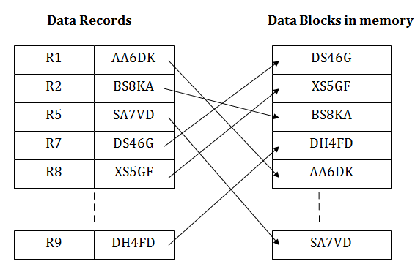
If any record has to be retrieved based on its index value, then the address of the data block is fetched and the record is retrieved from the memory.

Pros of ISAM:
- In this method, each record has the address of its data block, searching a record in a huge database is quick and easy.
- This method supports range retrieval and partial retrieval of records. Since the index is based on the primary key values, we can retrieve the data for the given range of value. In the same way, the partial value can also be easily searched, i.e., the student name starting with 'JA' can be easily searched.

Cons of ISAM
- This method requires extra space in the disk to store the index value.
- When the new records are inserted, then these files have to be reconstructed to maintain the sequence.
- When the record is deleted, then the space used by it needs to be released. Otherwise, the performance of the database will slow down.

File Operations
Operations on database files can be broadly classified into two categories −
- Update Operations
- Retrieval Operations
Update operations change the data values by insertion, deletion, or update. Retrieval operations, on the other hand, do not alter the data but retrieve them after optional conditional filtering. In both types of operations, selection plays a significant role. Other than creation and deletion of a file, there could be several operations, which can be done on files.
- Open − A file can be opened in one of the two modes, read mode or write mode. In read mode, the operating system does not allow anyone to alter data. In other words, data is read only. Files opened in read mode can be shared among several entities. Write mode allows data modification. Files opened in write mode can be read but cannot be shared.
- Locate − Every file has a file pointer, which tells the current position where the data is to be read or written. This pointer can be adjusted accordingly. Using find (seek) operation, it can be moved forward or backward.
- Read − By default, when files are opened in read mode, the file pointer points to the beginning of the file. There are options where the user can tell the operating system where to locate the file pointer at the time of opening a file. The very next data to the file pointer is read.
- Write − User can select to open a file in write mode, which enables them to edit its contents. It can be deletion, insertion, or modification. The file pointer can be located at the time of opening or can be dynamically changed if the operating system allows to do so.
- Close − This is the most important operation from the operating system’s point of view. When a request to close a file is generated, the operating system
  - removes all the locks (if in shared mode),
  - saves the data (if altered) to the secondary storage media, and
  - releases all the buffers and file handlers associated with the file.
The organization of data inside a file plays a major role here. The process to locate the file pointer to a desired record inside a file various based on whether the records are arranged sequentially or clustered.

DBMS - Indexing
We know that data is stored in the form of records. Every record has a key field, which helps it to be recognized uniquely.
Indexing is a data structure technique to efficiently retrieve records from the database files based on some attributes on which the indexing has been done. Indexing in database systems is similar to what we see in books.
Indexing is defined based on its indexing attributes. Indexing can be of the following types −
- Primary Index − Primary index is defined on an ordered data file. The data file is ordered on a key field. The key field is generally the primary key of the relation.
- Secondary Index − Secondary index may be generated from a field which is a candidate key and has a unique value in every record, or a non-key with duplicate values.
- Clustering Index − Clustering index is defined on an ordered data file. The data file is ordered on a non-key field.
Ordered Indexing is of two types −
- Dense Index
- Sparse Index

Dense Index
In dense index, there is an index record for every search key value in the database. This makes searching faster but requires more space to store index records itself. Index records contain search key value and a pointer to the actual record on the disk.
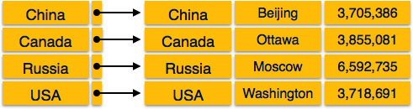

Sparse Index
In sparse index, index records are not created for every search key. An index record here contains a search key and an actual pointer to the data on the disk. To search a record, we first proceed by index record and reach at the actual location of the data. If the data we are looking for is not where we directly reach by following the index, then the system starts sequential search until the desired data is found.
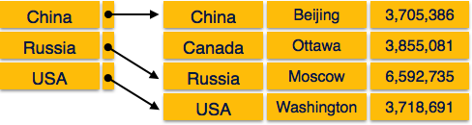

Multilevel Index
Index records comprise search-key values and data pointers. Multilevel index is stored on the disk along with the actual database files. As the size of the database grows, so does the size of the indices. There is an immense need to keep the index records in the main memory so as to speed up the search operations. If single-level index is used, then a large size index cannot be kept in memory which leads to multiple disk accesses.
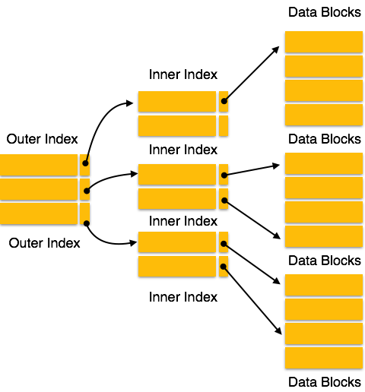
Multi-level Index helps in breaking down the index into several smaller indices in order to make the outermost level so small that it can be saved in a single disk block, which can easily be accommodated anywhere in the main memory.

B⁺ Tree
A B⁺ tree is a balanced binary search tree that follows a multi-level index format. The leaf nodes of a B⁺ tree denote actual data pointers. B⁺ tree ensures that all leaf nodes remain at the same height, thus balanced. Additionally, the leaf nodes are linked using a link list; therefore, a B⁺ tree can support random access as well as sequential access.

Structure of B⁺ Tree
Every leaf node is at equal distance from the root node. A B⁺ tree is of the order n where n is fixed for every B⁺ tree.
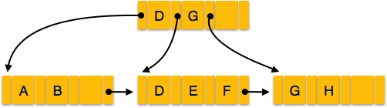
Internal nodes −
- Internal (non-leaf) nodes contain at least ⌈n/2⌉ pointers, except the root node.
- At most, an internal node can contain n pointers.
Leaf nodes −
- Leaf nodes contain at least ⌈n/2⌉ record pointers and ⌈n/2⌉ key values.
- At most, a leaf node can contain n record pointers and n key values.
- Every leaf node contains one block pointer P to point to next leaf node and forms a linked list.

B⁺ Tree Insertion
- B⁺ trees are filled from bottom and each entry is done at the leaf node.
- If a leaf node overflows −
  - Split node into two parts.
  - Partition at i = ⌊(m+1)_{/2}⌋.
  - First i entries are stored in one node.
  - Rest of the entries (i+1 onwards) are moved to a new node.
  - i^{th} key is duplicated at the parent of the leaf.
- If a non-leaf node overflows −
  - Split node into two parts.
  - Partition the node at i = ⌈(m+1)_{/2}⌉.
  - Entries up to i are kept in one node.
  - Rest of the entries are moved to a new node.

B⁺ Tree Deletion
- B⁺ tree entries are deleted at the leaf nodes.
- The target entry is searched and deleted.
  - If it is an internal node, delete and replace with the entry from the left position.
- After deletion, underflow is tested,
  - If underflow occurs, distribute the entries from the nodes left to it.
- If distribution is not possible from left, then
  - Distribute from the nodes right to it.
- If distribution is not possible from left or from right, then
  - Merge the node with left and right to it.

DBMS - Hashing
For a huge database structure, it can be almost next to impossible to search all the index values through all its level and then reach the destination data block to retrieve the desired data. Hashing is an effective technique to calculate the direct location of a data record on the disk without using index structure.
Hashing uses hash functions with search keys as parameters to generate the address of a data record.

Hash Organization
- Bucket − A hash file stores data in bucket format. Bucket is considered a unit of storage. A bucket typically stores one complete disk block, which in turn can store one or more records.
- Hash Function − A hash function, h, is a mapping function that maps all the set of search-keys K to the address where actual records are placed. It is a function from search keys to bucket addresses.

Static Hashing
In static hashing, when a search-key value is provided, the hash function always computes the same address. For example, if mod-4 hash function is used, then it shall generate only 5 values. The output address shall always be same for that function. The number of buckets provided remains unchanged at all times.
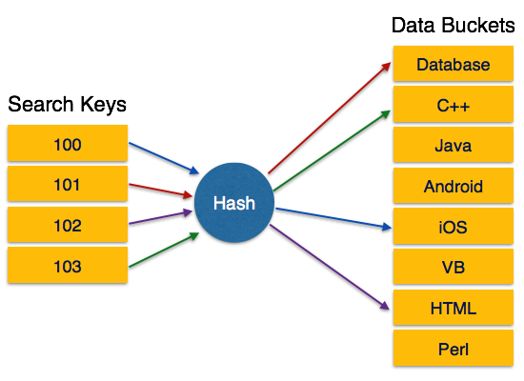

Operation
- Insertion − When a record is required to be entered using static hash, the hash function h computes the bucket address for search key K, where the record will be stored.
Bucket address = h(K)
- Search − When a record needs to be retrieved, the same hash function can be used to retrieve the address of the bucket where the data is stored.
- Delete − This is simply a search followed by a deletion operation.

Bucket Overflow
The condition of bucket-overflow is known as collision. This is a fatal state for any static hash function. In this case, overflow chaining can be used.
- Overflow Chaining − When buckets are full, a new bucket is allocated for the same hash result and is linked after the previous one. This mechanism is called Closed Hashing.
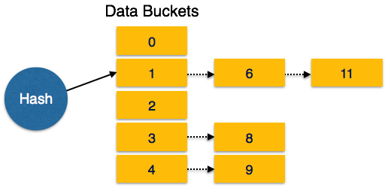
- Linear Probing − When a hash function generates an address at which data is already stored, the next free bucket is allocated to it. This mechanism is called Open Hashing.
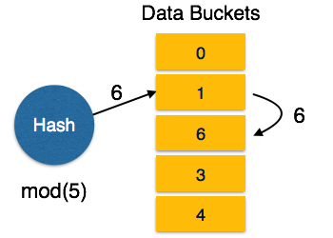

Dynamic Hashing
The problem with static hashing is that it does not expand or shrink dynamically as the size of the database grows or shrinks. Dynamic hashing provides a mechanism in which data buckets are added and removed dynamically and on-demand. Dynamic hashing is also known as extended hashing.
Hash function, in dynamic hashing, is made to produce a large number of values and only a few are used initially.
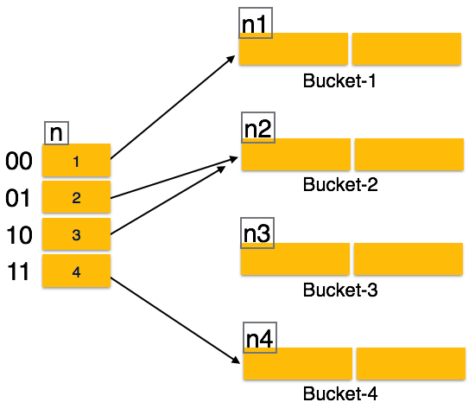

Organization
The prefix of an entire hash value is taken as a hash index. Only a portion of the hash value is used for computing bucket addresses. Every hash index has a depth value to signify how many bits are used for computing a hash function. These bits can address 2n buckets. When all these bits are consumed − that is, when all the buckets are full − then the depth value is increased linearly and twice the buckets are allocated.

Operation
- Querying − Look at the depth value of the hash index and use those bits to compute the bucket address.
- Update − Perform a query as above and update the data.
- Deletion − Perform a query to locate the desired data and delete the same.
- Insertion − Compute the address of the bucket
  - If the bucket is already full.
    - Add more buckets.
    - Add additional bits to the hash value.
    - Re-compute the hash function.
  - Else
    - Add data to the bucket,
  - If all the buckets are full, perform the remedies of static hashing.
Hashing is not favorable when the data is organized in some ordering and the queries require a range of data. When data is discrete and random, hash performs the best.
Hashing algorithms have high complexity than indexing. All hash operations are done in constant time.

Data Mining - Overview
There is a huge amount of data available in the Information Industry. This data is of no use until it is converted into useful information. It is necessary to analyze this huge amount of data and extract useful information from it.
Extraction of information is not the only process we need to perform; data mining also involves other processes such as Data Cleaning, Data Integration, Data Transformation, Data Mining, Pattern Evaluation and Data Presentation. Once all these processes are over, we would be able to use this information in many applications such as Fraud Detection, Market Analysis, Production Control, Science Exploration, etc.

What is Data Mining?
Data Mining is defined as extracting information from huge sets of data. In other words, we can say that data mining is the procedure of mining knowledge from data. The information or knowledge extracted so can be used for any of the following applications −
- Market Analysis
- Fraud Detection
- Customer Retention
- Production Control
- Science Exploration

Data Mining Applications
Data mining is highly useful in the following domains −
- Market Analysis and Management
- Corporate Analysis & Risk Management
- Fraud Detection
Apart from these, data mining can also be used in the areas of production control, customer retention, science exploration, sports, astrology, and Internet Web Surf-Aid

Market Analysis and Management
Listed below are the various fields of market where data mining is used −
- Customer Profiling − Data mining helps determine what kind of people buy what kind of products.
- Identifying Customer Requirements − Data mining helps in identifying the best products for different customers. It uses prediction to find the factors that may attract new customers.
- Cross Market Analysis − Data mining performs Association/correlations between product sales.
- Target Marketing − Data mining helps to find clusters of model customers who share the same characteristics such as interests, spending habits, income, etc.
- Determining Customer purchasing pattern − Data mining helps in determining customer purchasing pattern.
- Providing Summary Information − Data mining provides us various multidimensional summary reports.

Corporate Analysis and Risk Management
Data mining is used in the following fields of the Corporate Sector −
- Finance Planning and Asset Evaluation − It involves cash flow analysis and prediction, contingent claim analysis to evaluate assets.
- Resource Planning − It involves summarizing and comparing the resources and spending.
- Competition − It involves monitoring competitors and market directions.

Fraud Detection
Data mining is also used in the fields of credit card services and telecommunication to detect frauds. In fraud telephone calls, it helps to find the destination of the call, duration of the call, time of the day or week, etc. It also analyzes the patterns that deviate from expected norms.

Data Warehousing - Overview
The term "Data Warehouse" was first coined by Bill Inmon in 1990. According to Inmon, a data warehouse is a subject oriented, integrated, time-variant, and non-volatile collection of data. This data helps analysts to take informed decisions in an organization.
An operational database undergoes frequent changes on a daily basis on account of the transactions that take place. Suppose a business executive wants to analyze previous feedback on any data such as a product, a supplier, or any consumer data, then the executive will have no data available to analyze because the previous data has been updated due to transactions.
A data warehouses provides us generalized and consolidated data in multidimensional view. Along with generalized and consolidated view of data, a data warehouses also provides us Online Analytical Processing (OLAP) tools. These tools help us in interactive and effective analysis of data in a multidimensional space. This analysis results in data generalization and data mining.
Data mining functions such as association, clustering, classification, prediction can be integrated with OLAP operations to enhance the interactive mining of knowledge at multiple level of abstraction. That's why data warehouse has now become an important platform for data analysis and online analytical processing.

Understanding a Data Warehouse
- A data warehouse is a database, which is kept separate from the organization's operational database.
- There is no frequent updating done in a data warehouse.
- It possesses consolidated historical data, which helps the organization to analyze its business.
- A data warehouse helps executives to organize, understand, and use their data to take strategic decisions.
- Data warehouse systems help in the integration of diversity of application systems.
- A data warehouse system helps in consolidated historical data analysis.

Why a Data Warehouse is Separated from Operational Databases
A data warehouses is kept separate from operational databases due to the following reasons −
- An operational database is constructed for well-known tasks and workloads such as searching particular records, indexing, etc. In contract, data warehouse queries are often complex and they present a general form of data.
- Operational databases support concurrent processing of multiple transactions. Concurrency control and recovery mechanisms are required for operational databases to ensure robustness and consistency of the database.
- An operational database query allows to read and modify operations, while an OLAP query needs only read only access of stored data.
- An operational database maintains current data. On the other hand, a data warehouse maintains historical data.

Data Warehouse Features
The key features of a data warehouse are discussed below −
- Subject Oriented − A data warehouse is subject oriented because it provides information around a subject rather than the organization's ongoing operations. These subjects can be product, customers, suppliers, sales, revenue, etc. A data warehouse does not focus on the ongoing operations, rather it focuses on modelling and analysis of data for decision making.
- Integrated − A data warehouse is constructed by integrating data from heterogeneous sources such as relational databases, flat files, etc. This integration enhances the effective analysis of data.
- Time Variant − The data collected in a data warehouse is identified with a particular time period. The data in a data warehouse provides information from the historical point of view.
- Non-volatile − Non-volatile means the previous data is not erased when new data is added to it. A data warehouse is kept separate from the operational database and therefore frequent changes in operational database is not reflected in the data warehouse.
Note − A data warehouse does not require transaction processing, recovery, and concurrency controls, because it is physically stored and separate from the operational database.

Data Warehouse Applications
As discussed before, a data warehouse helps business executives to organize, analyze, and use their data for decision making. A data warehouse serves as a sole part of a plan-execute-assess "closed-loop" feedback system for the enterprise management. Data warehouses are widely used in the following fields −
- Financial services
- Banking services
- Consumer goods
- Retail sectors
- Controlled manufacturing

Types of Data Warehouse
Information processing, analytical processing, and data mining are the three types of data warehouse applications that are discussed below −
- Information Processing − A data warehouse allows to process the data stored in it. The data can be processed by means of querying, basic statistical analysis, reporting using crosstabs, tables, charts, or graphs.
- Analytical Processing − A data warehouse supports analytical processing of the information stored in it. The data can be analyzed by means of basic OLAP operations, including slice-and-dice, drill down, drill up, and pivoting.
- Data Mining − Data mining supports knowledge discovery by finding hidden patterns and associations, constructing analytical models, performing classification and prediction. These mining results can be presented using the visualization tools.
Sr.No. | Data Warehouse (OLAP) | Operational Database(OLTP)
1 | It involves historical processing of information. | It involves day-to-day processing.
2 | OLAP systems are used by knowledge workers such as executives, managers, and analysts. | OLTP systems are used by clerks, DBAs, or database professionals.
3 | It is used to analyze the business. | It is used to run the business.
4 | It focuses on Information out. | It focuses on Data in.
5 | It is based on Star Schema, Snowflake Schema, and Fact Constellation Schema. | It is based on Entity Relationship Model.
6 | It focuses on Information out. | It is application oriented.
7 | It contains historical data. | It contains current data.
8 | It provides summarized and consolidated data. | It provides primitive and highly detailed data.
9 | It provides summarized and multidimensional view of data. | It provides detailed and flat relational view of data.
10 | The number of users is in hundreds. | The number of users is in thousands.
11 | The number of records accessed is in millions. | The number of records accessed is in tens.
12 | The database size is from 100GB to 100 TB. | The database size is from 100 MB to 100 GB.
13 | These are highly flexible. | It provides high performance.

Data Mining vs Data Farming
Data mining is the process of digging through data sets to find patterns, correlations, and trends. It’s using the data that already exists and has been collected. Similar to a miner that digs in the earth to find gems. For HR, the gems are the metrics. It’s tracking historical turnover data to see if you’re retaining people of color to support your inclusion efforts. Another would be looking at the data of high performers to identify patterns in their training and education history. You can use the information to create a training program.
Data farming is cultivating and acquiring data specifically for forecasting and modeling. The information is used to plan for different business situations and identify solutions proactively. HR teams that are at the fourth level of HR analytics maturity may use data farming in their prescriptive analytics.

NUMERCALS
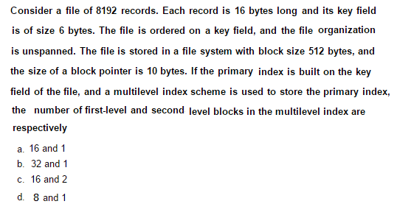
Answer: DB size 512
record size 16
no of record possible in disk block 512/16=32 records/block
no of Disk block present in DB file 8192/32=256
so primary index is used which is called as sparse index .in this index we make entry of each disk block but not of every record.!
so at first level we have =256/(index file size )
now wt is index file : with the help of block pointer and search we locate reocrds so index file size =512/(6+10)
=512/16 =32 (records per index )
so at first level we have 256/32=8 index blocks
and hence multilevel index is used so in last level we have only 1 index block
so (d ) ans.

Question: Consider a database of fixed-length records, stored as an ordered file. The database has 25,000 records, with each record being 100 bytes, of which the primary key occupies 15 bytes. The data file is block-aligned in that each data record is fully contained within a block. The database is indexed by a primary index file, which is also stored as a block-aligned ordered file. The figure below depicts this indexing scheme.
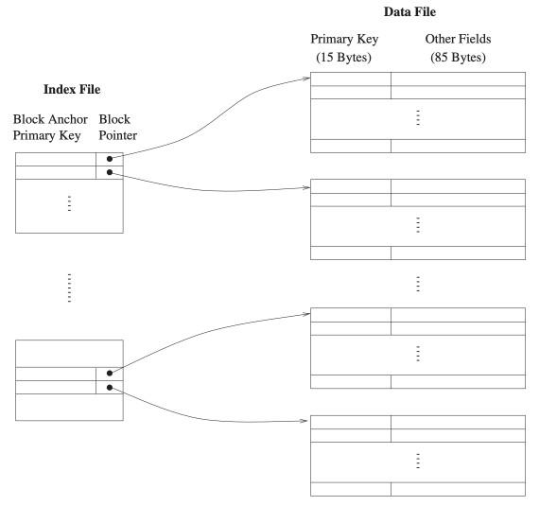
Primary Indexing
Suppose the block size of the file system is 1024 bytes, and a pointer to a block occupies 5 bytes. The system uses binary search on the index file to search for a record with a given key. You may assume that a binary search on an index file of b blocks takes ⌈log2⁡b⌉ block accesses in the worst case. Given a key, the number of block accesses required to identify the block in the data file that may contain a record with the key, in the worst case, is _______.

Solution:
As it is given it is fixes length record,
So one block should fully contain within block so here it means
that they are saying that you should use un-spanned file organization.
=> No. of Records(Rn) = 25,000
=> Size of Record(Rs) = 100 Bytes
=> Size of Key(Ks) = 15 Bytes
=> Block Pointer Size(Ps) = 5 Bytes
So , Index Size(Is) = Size of Key + Block Pointer Size = 15 + 5 = 20 Bytes
Disk Block Size(Bs) = 1024 Bytes
=> No. of Record per Block = ⌊(Disk Block Size/Record Size)⌋
= ⌊1024⌋ = ⌊10.24⌋ = 10
=> No. of Block Required for record = ⌈( no. of record / no of record per block)⌉
= ⌈ 25000/10 ⌉ = 2500
=> The database is indexed by a primary index file it means,
that here we have to use sparse indexing.
=> No. of Index per Block =⌊(Disk Block Size/Index Size)⌋
= ⌊ (1024/20) ⌋
= 51 index per blocks
=> No. of Block Required for indexes = ⌈ ( No. of index /No. of index per block) ⌉
= ⌈ 2500/51 ⌉
= 50
=> It is given that Binary Search is used to search the desired block
and we know that it takes (log n) time to search in worst case
where n is the no. of comparison required
=> Here No. of comparison = No. of Index Block
=> Hence the number of block accesses required to identify the block in
the data file that may contain a record with the key,
in the worst case, is (log 50) = 6 Blocks

How Searching Happens in an Indexed Database?
The database does a search in the B-tree for a given key and returns the index in O(log(n)) time. The record is then obtained by running a second B+tree search in O(log(n)) time using the discovered index. So overall approx time taken for searching a record in a B-tree in DBMS-indexed databases is O(log(n)).

Examples of B-Tree
Suppose there are some numbers that need to be stored in a database, so if we store them in a B-tree in DBMS, they will be stored in a sorted order so that the searching time can be logarithmic.
Let's take a look at an example:

The above data is stored in sorted order according to the values, if we want to search for the node containing the value 48, the following steps will be applied:
- First, the parent node with a key having data 100 is checked, as 48 is less than 100 so the left children node of 100 is checked.
- In left children, there are 3 keys, so it will check from the leftmost key as the data is stored in sorted order.
- The leftmost element is having key value as 48 which matches the element to be searched, that we wanted to search.
